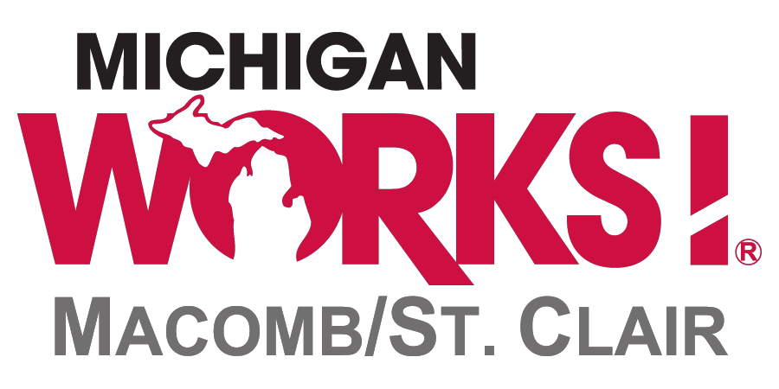

INSTRUCTIONS AND APPLICATION FOR BID
FOR THE CLEANING AND CUSTODIAL SERVICES
OF THE CLINTON TOWNSHIP, MT. CLEMENS, & ROSEVILLE
MICHIGAN WORKS! CAREER CENTERS FOR THE PERIOD OF
JULY 1, 2023 THROUGH JUNE 30, 2025

- INTRODUCTION & PURPOSE

This preliminary questionnaire is being issued by the Macomb/St. Clair Workforce Development Board (referred to elsewhere in these instructions as "M/SCWDB") as an invitation to qualified cleaning and custodial service companies to submit a bid to provide regular cleaning services at the Michigan Works! Career Center(s) in the following locations:

Clinton Township Michigan Works! Career Center
43630 Hayes Road, Suite
Suites 100, 240, and 250
Clinton Township, MI 48038
Roseville Michigan Works! Career Center
15950 Twelve Mile Road
Roseville, MI 48066
Mt. Clemens Michigan Works! Career Center
75 North River Road
Mt. Clemens, MI 48043

All of the MW! Career Centers operate on Monday through Friday schedule from 8:00 a.m. until
5:00 p.m. Contracts will be awarded through this bid process covering the period beginning on
July 1, 2023 and running through June 30, 2025.

- DESCRIPTION OF PROPERTIES

Clinton Township MW! Career Center (contains 3 Suites)
Suite #100 contains approximately 12,618 SF with 28 rooms and 13 separate office cubicles/work areas. 1 room has vinyl flooring. 8 rooms have tile floors accounting for approximately 2,040 SF of space. The remaining units are carpeted.

Suite #250 contains 4,462 SF of mostly carpeted space with 7 cubicles, 4 offices, 3 meeting rooms, a kitchen area (tiled), 2 restrooms (tiled) and a copy room.

Suite #240 covers 2,975 SF of mostly carpeted space. It includes a large waiting/reception area, 5 offices, a lounge (tiled), 2 restrooms (tiled), and a conference room.

The Roseville MW! Career Center contains approximately 11,273 SF with approximately 26 rooms and 20 separate office cubicles/work areas. 8 of those rooms have tile floors (The Lunchroom, the entry way, the Communications room, the Utility room, and the 4 restrooms) accounting for approximately 1,739 SF of space. The remaining units are carpeted.

The Mt. Clemens MW! Career Center contains approximately 5,122 SF of mostly carpeted space. It includes a customer registration area along with 14 office cubicles, a lobby area, 2 tiled restrooms, 1 tiled utility/communications room and assorted classrooms and 1office.

Prospective Bidders are invited to visit the Michigan Works! Career Centers during regular business hours (8:00 a.m. to 5:00 p.m. on Monday thru Friday) to obtain a firsthand look at any or all of the properties. Contact Allan Eisenhauer at (586) 469-6685 or allan.eisenhauer@msc-mw.org to make an appointment.

The building cleaning hours would be scheduled following the close of business on Monday through Friday. In addition to Saturdays and Sundays, the buildings will be closed for a total of 13 weekdays in observance of the following holidays:

New Year's Day | Election Day (during even numbered years)
Martin Luther King's Birthday | Veterans Day
President's Day | Thanksgiving Day (2 days, Thursday and Friday)
Memorial Day Independence Day  Juneteenth | Christmas Eve
Independence Day | Christmas Day
Labor Day | New Year’s Eve

Cleaning and maintenance services will not be required on those dates. A complete schedule of the
dates of these closings will be provided to the Contractor selected through this bid process.

III. SERVICES & RESPONSIBILITIES

Guidance provided by the CDC regarding cleaning of public spaces can be found at:
https://www.cdc.gov/coronavirus/2019-ncov/community/reopen-guidance.html
Among the services that the cleaning and maintenance service provider will be expected to perform are the following:

Daily Services (approximately 248 days per year)

- Empty trash and waste baskets throughout the building. Replace plastic waste basket liners as necessary.

- Dust desks chairs, and other office furniture, classroom desks, tables, and chairs, windowsills, ledges and all flat surfaces using disinfectant.

- Vacuum carpeting and sweep tile surfaces throughout the building.

- Clean glass surfaces within the building including all windows and doors.

- Spot clean doors, frames, and light switches.

- Wipe clean lunchroom and snack room tables and counters.

- Dust baseboards, chair and table legs, and window and door moldings throughout the building.

- Mop tile floors on an "as-need" basis and at a minimum of once per week.

- Clean restrooms thoroughly using disinfectant.

- Check and restock supplies in restrooms including toilet paper and hand towels.

- Empty restroom trash containers.

- Sweep and mop restroom floors using a disinfectant.

- Spot clean walls and restroom partitions.

- Clean all commodes and urinals.

- Clean bathroom restroom sinks and polish faucets and mirrors.

- Replace fluorescent lamps when necessary.

- Brush down air vents when necessary

Once Per Month (12 times per year)

- Buff all tile floors.

Quarterly (4 times per year)
- Clean all exterior windows.
- Scrub, strip, reseal, and rewax tile floors.
Semiannual (twice per year)

- Shampoo carpeting

- Wash interior windows

NOTE: The M/SCWDB may not strictly adhere to the schedule of "Services & Duties" and may request that some of these services be completed more frequently than appears on this schedule. For example, if the carpet becomes severely stained, it may be necessary to schedule an additional carpet cleaning.

SUPPLIES

Please note that the service provider selected to provide services through this RFP process will be expected to provide the following cleaning supplies:

- Disinfectant (Must be approved by CDC as effective against COVID-19)
- Chemical Cleaning Supplies
- Garbage Bags
- Trash Can Liners
- Urinal Cakes
- Toilet Paper
- Paper Towels
- Seat Covers
- Soap
- Any and all tools required to perform services

The cost of such supplies should be included in your bid.

- GENERAL DIRECTIONS, SPECIFICATIONS, AND INFORMATION

(IMPORTANT: Please submit a separate questionnaire for each center for which you wish to submit a bid.) A separate contract for each individual center is proposed on the basis of this preliminary questionnaire. Your bid(s) should be responsive to the information being requested in this request for proposal. The Macomb/St. Clair Workforce Development Board may award a contract based on bids received without discussion with the bidders. Each bid should therefore be submitted in the most favorable terms from a price and technical standpoint, which the proposer can make to the M/SCWDB. The charges listed should be valid for the length of the contract. The M/SCWDB reserves the right to request additional data, discussion, or a presentation in support of written bids. In order to receive consideration, bidders must be registered on the “Federal Contractor Registry” (http://www.sam.gov) and be in good standing.

Format

An application is included as part of this packet. It must be filled out completely. Do not submit information that is not requested. Submit attachments only where requested. This bid solicitation is a competitive process. Bidders are therefore advised to present their bids in the most favorable light possible.

Scoring of Proposals

Proposals will be reviewed and scored on a 100-point basis. Proposals will be judged and scored on the following criteria:

Criteria Possible # of Points Earned

Daily Service Charge: 30 points

Monthly Service Charge: 35 points

Quarterly Service Charge: 20 points

Semiannual Service Charge: 15 points

Supply charges 10 points

Audits and Investigations

The organization contracted to provide the requested services must agree to cooperate with any monitoring, inspections, audits, or investigations of activities related to this agreement that may be conducted by the Macomb/St. Clair Workforce Development Board, the County of Macomb, the State of Michigan, the United States Department of Labor, and/or any of their designated representatives.

Contractual Policies

The organization or "contractor" selected through this bid process to provide the requested service
will enter into a service contract with the M/SCWDB that will cover the period of July 1, 2023
through June 30, 2025. Under this contract, the contractor will bill the M/SCWDB for services rendered on a monthly basis by the 10th of the following month.

Limitations

This preliminary questionnaire does not commit the Macomb/St. Clair Workforce Development Board to award a contract, to pay any costs incurred in the preparation of a proposal prepared in response to the solicitation, or to procure or contract for services or supplies. The M/SCWDB reserves the right to accept or reject any or all bids received as a result of this solicitation, to negotiate with all qualified bidders, or to cancel this request for bids if it is in the best interest of the M/SCWDB to do so.

Response Requirements

In order to receive consideration, bids must be labeled as "Custodial Services Bid", and dropped off or mailed to the following address:

Mr. Justin Al-Igoe, Executive Director
Macomb/St. Clair Workforce Development Board
Verkuilen Building
21885 Dunham Road, Suite #11
Clinton Township, MI 48036-1030

Due Date

Bids must be received in the offices of the M/SCWDB no later than 4:00 p.m. on Friday, June 2nd, 2023. Bids received after that date will not be accepted for consideration. Bids received prior to that time will remain sealed, will be time stamped and held in a secure location until 9:00 a.m. on Monday, June 5th, 2023. At that time, all bids will be opened and recorded in the administrative offices of the Workforce Development Board.

Cancellation

M/SCWDB reserves the right to cancel contracts based on performance and or funding cuts. M/SCWDB will provide a 90 day notice to the vendor that the contract is being terminated along with the final day that the services will be needed.

Questions

Questions about this bid process can be directed to Allan Eisenhauer at (586) 469-6685 or by e-mail at: Allan.Eisenhauer@msc-mw.org.

An electronic copy of this bid form, in Word format, can be obtained by visiting: Home - Michigan Works! Macomb/St. Clair (msc-mw.org)
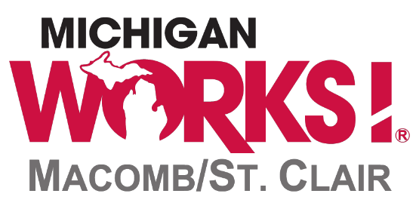

MICHIGAN WORKS! CAREER CENTER
CLEANING AND CUSTODIAL SERVICES BID APPLICATION
FOR THE PERIOD OF
July 1, 2023 THROUGH JUNE 30, 2025

INTRODUCTION

This application must be completed and returned labeled as "Custodial Services Bid" to the attention of:

Mr. Justin Al-Igoe, Executive Director
Macomb/St. Clair Workforce Development Board
Verkuilen Building
21885 Dunham Road, Suite #11
Clinton Township, MI 48036-1030

Bids must arrive in the offices of the Workforce Development Board no later than 4:00 p.m. on Friday, June 2nd, 2023. An electronic copy of this bid form, in Word format, may be obtained by visiting: Home - Michigan Works! Macomb/St. Clair (msc-mw.org/rfp/)

- IDENTIFYING INFORMATION

A.
NAME OF BUSINESS

STREET ADDRESS

CITY/STATE/ZIPCODE

B.
CONTACT PERSON/TITLE

PHONE NUMBER FAX NUMBER

E-MAIL ADDRESS

- BID SUBMITTED FOR THE FOLLOWING LOCATION:

A separate bid is required for each site for any proposer bidding on more than one site.

CLINTON TWP. MT. CLEMENS ROSEVILLE

- BACKGROUND INFORMATION

- How many years of experience has your company had in providing custodial services?

- Provide a list of the names of some of your current or previous customers.

May we contact those references?

Yes No

(Please attach list to this questionnaire)

- BID
Cost Breakdown: For each of the Career Centers, please list your fees to provide the services requested and described in the above narrative. Fees should be broken down to a "per visit" basis.

Daily Services: $

Monthly Services: $

Quarterly Services: $

Semiannual Services: $

Breakdown of supplies: $ .

- ADDITIONAL INFORMATION

Provide documentation that the company is bonded and insured.

Is the company registered on the Federal Contractor Registry? (http://www.sam.gov )

Yes No

If you would like to provide any additional information about your company and/or your ability to provide the requested service, please list it here. You may include an attachment if necessary.

- BIDDER'S SIGNATURE PAGE

Please provide all requested information as part of your response.

  - Bidding under the name of:

  - Federal Employer Identification Number:

C. Type of Organization: Private-For-Profit

Public/Non-Profit

Private/Non-Profit

D. List the address that payment should be directed to if awarded this contract.

- Is the owner or any employee of the organization submitting this bid associated with, or have a family member serving on the Macomb/St. Clair Workforce Development Board, the Macomb or St. Clair County Board of Commissioners, or as an administrative employee of the Macomb/St. Clair Workforce Development Board? Yes No

If "Yes", identify whom that individual is, the person that he or she is associated with, the position held by each of these individuals, and the relationship that exists between them.

I certify that this proposal is a firm offer to provide cleaning and custodial services at the Michigan Works! Career Center between the dates of July 1, 2023, and June 30, 2025. I certify that the organization that I represent will maintain complete and accurate records for a period of 3 years justifying all charges to the Macomb/St. Clair Workforce Development Board for work rendered should a contract be awarded through this bid process. Such records will leave a clear audit trail to the point of origin.

The organization contracted to provide the requested services must agree to cooperate with any monitoring, inspections, audits, or investigations of activities related to this agreement that may be conducted by the Macomb/St. Clair Workforce Development Board, the County of Macomb, the State of Michigan, the United States Department of Labor, and/or any of their designated representatives.

This document must be signed by an appropriate representative of the organization submitting this bid who has signatory authority for entering into contracts on behalf of the organization.

Print Name and Title

Authorized Signature/Date

Address Phone Number / Fax Number

